Blog Posting Exercise
BMGT45540: Managing Innovative Projects — 2026 Study Guide extract
This document reproduces Section 5.2 and Appendix II of the BMGT45540 Managing Innovative Projects 2026 Study Guide (updated 25 June 2026). Section 5.2 describes the blog post assignment (the “PM Challenge 2026”) and Appendix II gives the step-by-step instructions for publishing a post on the class blog. The peer assessment of other students’ blogs (Section 5.3) is described in a separate document. Hyperlinks have been preserved from the original.

At a glance
Component | Weight | What you produce | How it is submitted
5.2 Blog post (“PM Challenge 2026”) | 30% | A public blog post of 900–1,100 words on how one existing organization is facing one of six megatrends, answering five set questions, with hyperlinked sources, a category, tags and a featured image. | Publish on the class blog via the invitation link; fill out the Google form; complete the BrightSpace Word template; convert it to PDF; upload the PDF to the BrightSpace Assignment.

5.2 Blog post, or “PM Challenge 2026” (30%)
The goal of the PM Challenge 2026 is to promote peer learning and discussion on the impact of a megatrend on business and society. Megatrends are powerful, transformative forces that can change the trajectory of the global economy by shifting the priorities of societies, driving innovation and re-defining business models. Progress depends on change-makers, people who see opportunity and solutions in the midst of crisis.
Project professionals are, of course, born change-makers. Organizations have long turned to project managers and professionals with project skills to help them turn ideas into reality. What truly sets us apart is our focus on implementation, figuring out how to make something concrete out of an audacious goal. This skill set will be more indispensable in the years ahead than ever before, as the world grapples with megatrends.
In this Challenge, you will investigate how an organization is addressing one of the following megatrends (presented in no particular order):
- Global power shifts and geopolitical realignments
- The future of work and workforce transformation
- Digital transformation
- Sustainability and climate change
- Demographic shifts and urbanization
- Health and well-being revolution
These megatrends are likely to have a meaningful impact not just on how we live and work, but also on government policies and corporate strategies in the coming years of your career.
The PM Challenge 2026 requires you to conduct research and write a blog post (see note 1) that examines how one organization (see note 2) of your choice is facing a particular aspect of one of these megatrends. I highly encourage you to “think big” on what company and megatrend you are choosing to focus on. You may also use this blog posting as an opportunity to research your dream employer.
Note 1 — In terms of overall style, a blog post is different than a traditional essay/assignment. That is, it should contain hypertext to refer to sources of information shared (as opposed to having references in the end) and it may contain figures or tables. Examples of past student blog posts are already provided in our class blog.
Note 2 — Such an organization must currently exist in the world (i.e. it cannot be a defunct business, or a project that you hope it will eventually lead to a start-up) and it can be of any size, geography, sector etc. For example, it could be a start-up, a listed company, a government, a for-profit, or an NGO organization located in Ireland, India, Germany or anywhere in the world. However, I hope that this module and this specific exercise will push you to study deeper an important organization (and not merely a small local enterprise).
Your blog post should address the following five questions in the context of the organization you choose:
- Why do you think the megatrend you selected is important to your organization’s management?
- How will the organization’s management be affected (either positively or negatively) by the megatrend you selected?
- What steps is the organization’s management currently taking to mitigate these effects in the short term (the next two years) and the medium term (two to ten years out)?
- What other steps do you recommend the organization’s management take to address this issue in the short and medium terms?
- In the context of this organization, what are one or two important open questions related to this issue that you are unsure about that merit comments from your classmates?
Your blog post should convey facts, analysis, and your recommendations. It should focus on a single organization (e.g., a single company, non-profit organization, or government agency) and a concern related to one of the above megatrends. (It is fine if the concern you chose also relates to other megatrends that the organization is facing, but that is not required.)
The formatting specifications of each blog post are entirely up to each student. Roughly a quarter of your blog post should be dedicated to each of the first four questions, with just a few sentences dedicated to the last question.
Your blog post should be at least 900 words but no more than 1,100 words, excluding any text on tables, table captions, figure captions, appendices, or links used (see also Appendix II on how you should make your first blog posting). You should appropriately reference any of the sources of information you are mentioning using hyper-links (as opposed to references in the end). I highly encourage you to read and reference top outlets such as FT50 research journals, Harvard Business Review, MIT Sloan Review, California Management Review, The Economist, Business Week, Forbes, and major newspapers or trustworthy articles on the web.
Use this invitation link to submit your blog post to our class blog canvas. While submitting, make sure you select your chosen megatrend by clicking on the respective blog Category field (e.g. “Business Sustainability”). Please also select an informative featured image (i.e. an image that relates very well or summarizes your blog post and will be displayed on the final “canvas” of all blogs created) and appropriate tags/hashtags to accompany your blog post. All class blogs created will be posted in public to our class blog (https://ucdprojectmanagement.edublogs.org/) once this assignment is due.

Submission steps
Once your blog post is complete and made public, please follow these steps:
- Fill out this Google form. Ensure all required information is provided accurately.
- Download the designated Template from BrightSpace. Complete the template with the required details as specified. No additional information is necessary beyond what is outlined in the template.
- Convert the completed Word Template to PDF.
- Upload the PDF file to the relevant “Assignment” section on BrightSpace. (Multiple submissions are allowed; however, I will typically grade the most recent submission unless you explicitly specify otherwise in the comments section.)
Before submitting, ensure your blog post is publicly accessible:
- Open it in your browser using an incognito/private mode. If it opens without any access issues, it is public.
- If it does not open, revisit the blog’s settings to confirm it is not marked as “private” or address any other accessibility issues. It is crucial that your blog post is publicly accessible, as your peers will need to read and evaluate it as part of the next phase of the assignment (Section 5.3, Others’ blog assessment).

Evaluation criteria
Your blog post will be evaluated according to the following criteria:
- Does the post demonstrate depth and provide meaningful, informative content, or does it feel superficial, as if generated by AI in a matter of minutes?
- What aspects of the post were interesting or insightful?
- What did we learn from the post?
- Are there any concerns about the content, such as inaccuracies, unrealistic recommendations, or the presence of fake information?
- Have you grounded your analysis in rigorous, high-quality research from top outlets such as FT50 journals, Harvard Business Review, MIT Sloan Review, or The Economist, and does your post clearly reflect and build on those insights rather than merely citing them in passing?
Overall, this blog post activity allows students to synthesize the knowledge gained from our module and combine it with their own experience and research. See also Appendix II for further instructions and submission guidance.

Appendix II: Blog posting instructions
Please follow the following steps to create your blog post.

Step 1: Sign up to the class blog
Click my invitation link and sign up to our class blog using a username and password of your choice as seen below. Please do not share this link with anyone outside our class. Upon creating your blog post, your classmates will review and evaluate it. To preserve anonymity in the review process and obtain more objective feedback, I recommend you use a non-identifying username.
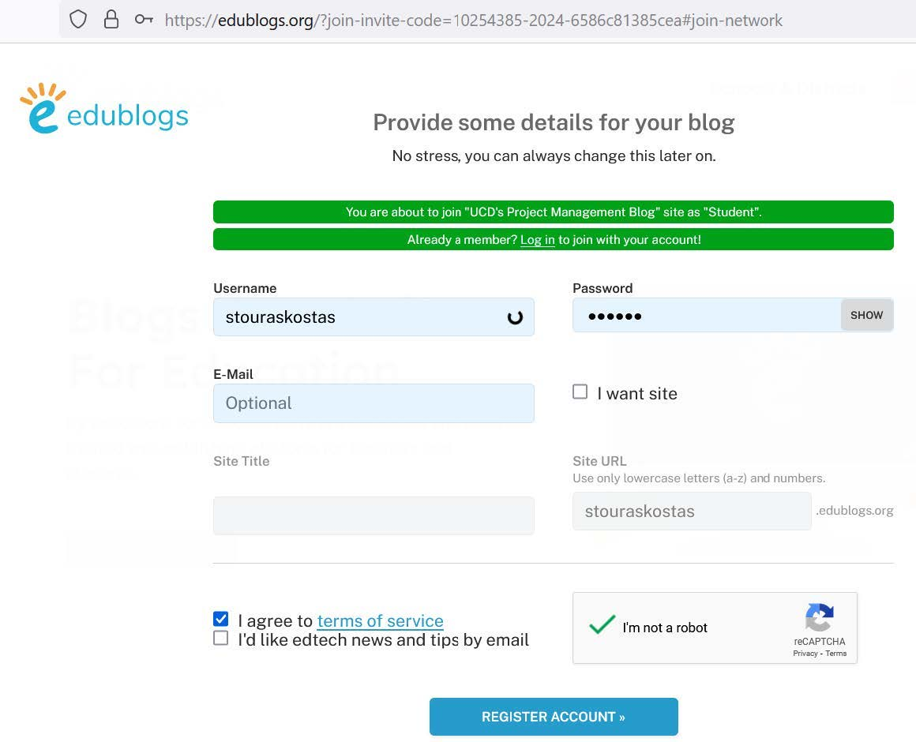
Figure 1: Sign-up screen of our class blog.

Step 2: Complete the registration
Once you click “I’m not a robot” and complete the reCAPTCHA challenge you will be guided to the following screen.
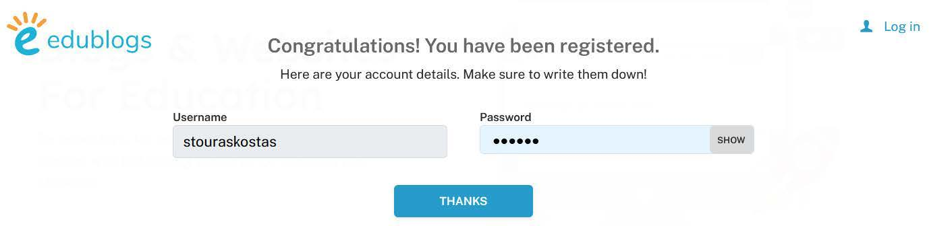
Figure 2: Registration is complete.

Step 3: Open a new post
Refresh your page and click my invitation link once more (if needed). (Ignore the message: “Need an Edublogs Network for your school or District? CampusPress will provide you with the solution you are looking for.”)
You will be guided to the following screen where you should press “+ New” as shown in the red circle below. Then, press “Post” to be guided to a new screen where you can compose your blog post.
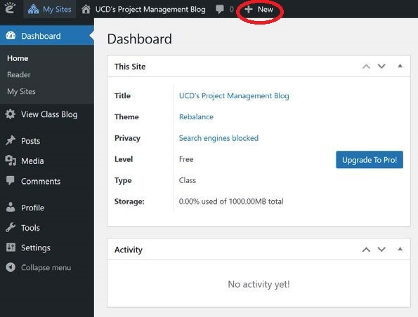
Figure 3: Step 3.

Step 4: Compose your blog post
Compose your blog post. A blog post must look like a blog post (as opposed to a traditional essay or assignment). Choose a relevant title. Pictures, videos, tables, statistics or other facts and references to your sources (via hypertext as in Wikipedia) are strongly encouraged! Specify a “category” corresponding to the megatrend of your focus. Browse through past blog posts available to get a few examples.
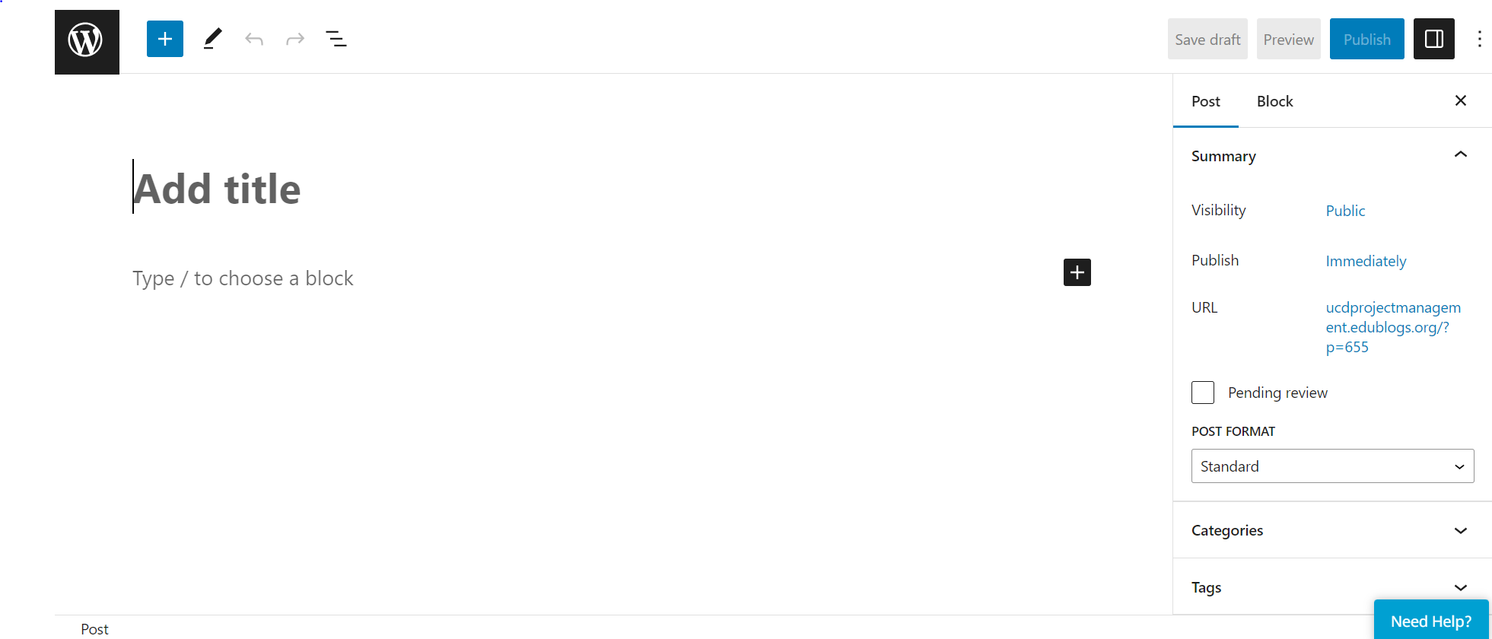
Figure 4: Blog post composition.

Step 5: Add tags and save a backup
Choose relevant tags (i.e. keywords) for your blog post. If you want to save your draft, click “Save Draft”. In addition, I strongly encourage you to save (back up) your post in Word or Google Docs as well. This way you minimize the chance of some glitch happening.

Step 6: Add a featured image
Do not forget to add a cool “Featured Image” to your post. It could be an image that summarizes your blog post or the logo of the company you analyzed. Eventually, all blog posts will be shown on our class blog canvas as either a short text prompt or a featured image (if used) accompanied by a short text (see past blog posts available to get some ideas).
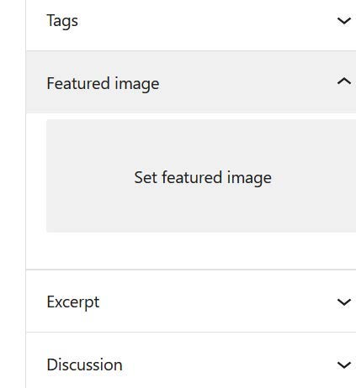
Figure 5: Adding a featured image to your blog post.

Step 7: Ignore the temporary link
Before pressing the “Publish” button you would be shown a link to your post ending with p=A NUMBER. Please ignore that temporary link.

Step 8: Publish and save the permanent link
When you have finished your blog post, click the blue button “Publish” on the top right making sure the field visibility is set to “Public” (whereas the box pending review is unticked). You will be guided to a window showing the permanent “post address” URL to your blog post. Save this permanent link to refer to your blog post when asked in the next step. For instance, in the figure below it is shown the URL https://ucdprojectmanagement.edublogs.org/2025/01/15/test (which is not ending with “p=A NUMBER”).
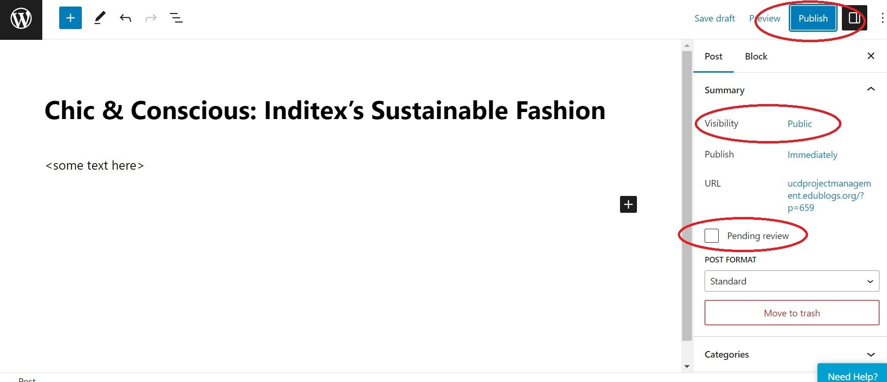 | 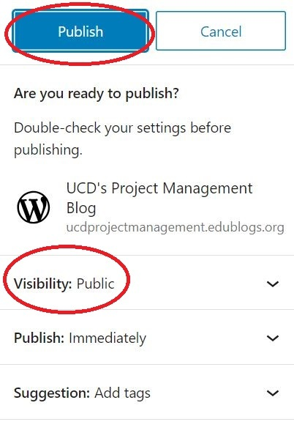
Figure 6: Publishing your blog post.

Step 9: Report your post on BrightSpace
Once you have composed your blog post and made it public, you must (i) fill up this Google form, and (ii) download the respective Template available on BrightSpace. No other information is required other than whatever is mentioned in the Template. Then, (iii) convert your Word template file to PDF and (iv) upload it on BrightSpace in the relevant “Assignment” option.
Source: BMGT45540 Managing Innovative Projects 2026 Study Guide (updated 25 June 2026), Section 5.2 and Appendix II.

